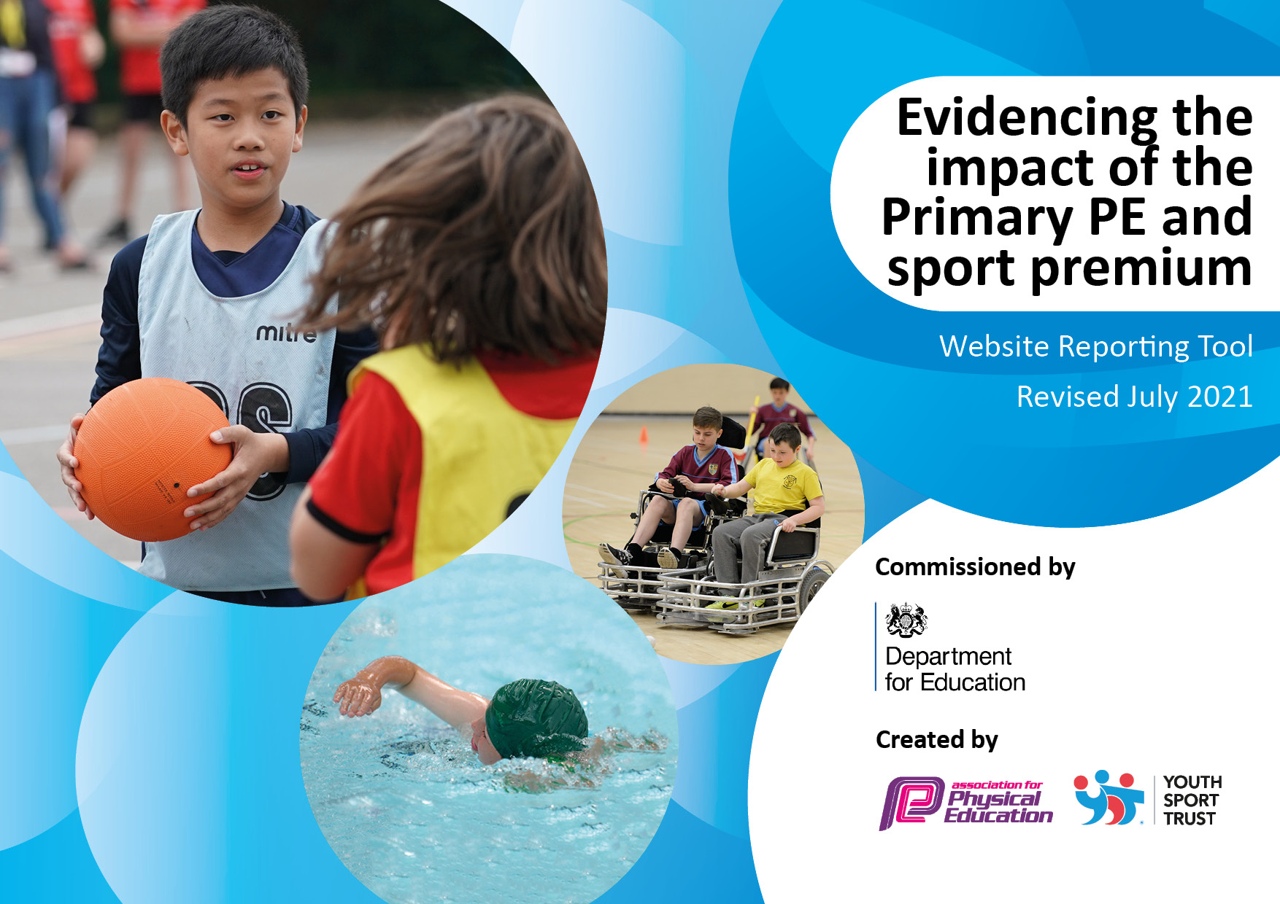

It is important that your grant is used effectively and based on school need. The Education Inspection Framework makes clear there will be a focus on ‘whether leaders and those responsible for governors all understand their respective roles and perform these in a way that enhances the effectiveness of the school’.

Under the Quality of Education Ofsted inspectors consider:
Intent - Curriculum design, coverage and appropriateness
Implementation - Curriculum delivery, Teaching (pedagogy) and Assessment
Impact - Attainment and progress

To assist schools with common transferable language this template has been developed to utilise the same three headings which should make your plans easily transferable between working documents.

Schools must use the funding to make additional and sustainable improvements to the quality of Physical Education, School Sport and Physical Activity (PESSPA) they offer. This means that you should use the Primary PE and sport premium to:

- Develop or add to the PESSPA activities that your school already offer
- Build capacity and capability within the school to ensure that improvements made now will benefit pupils joining the school in future years
- The Primary PE and sport premium should not be used to fund capital spend projects; the school’s budget should fund these.

Pleasevisitgov.ukfortherevisedDfEguidanceincludingthe5keyindicatorsacrosswhichschoolsshoulddemonstrate animprovement.Thisdocumentwillhelpyoutoreviewyourprovisionandtoreportyourspend.DfEencouragesschools to use this template as an effective way of meeting the reporting requirements of the Primary PE and sport premium.

We recommend you start by reflecting on the impact of current provision and reviewing the previous spend.

Schools are required to publish details of how they spend this funding, including any under-spend from 2019/2020, as well as on the impact it has on pupils’ PE and sport participation and attainment. All funding must be spent by 31st July 2022.

We recommend regularly updating the table and publishing it on your website throughout the year. This evidences your ongoing self-evaluation of how you are using the funding to secure maximum, sustainable impact. Final copy must be posted on your website by the end of the academic year and no later than the 31st July 2021. To see an example of how to complete the table please click HERE.
Created by: Supported by:

Details with regard to funding
Please complete the table below.

Total amount carried over from 2019/20 | £0
Total amount allocated for 2020/21 | £
How much (if any) do you intend to carry over from this total fund into 2021/22? | £2,000
Total amount allocated for 2021/22 | £17,670
Total amount of funding for 2021/22. To be spent and reported on by 31st July 2022. | £19,670
Swimming Data
Please report on your Swimming Data below.

Meeting national curriculum requirements for swimming and water safety.

N.B. Complete this section to your best ability. For example you might have practised safe self-rescue techniques on dry land which you can then transfer to the pool when school swimming restarts.
Due to exceptional circumstances priority should be given to ensuring that pupils can perform safe self rescue even if they do not fully meet the first two requirements of the NC programme of study
What percentage of your current Year 6 cohort swim competently, confidently and proficiently over a distance of at least 25 metres?  N.B. Even though your pupils may swim in another year please report on their attainment on leaving primary school at the end of the summer term 2020.  Please see note above | %
What percentage of your current Year 6 cohort use a range of strokes effectively [for example, front crawl, backstroke and breaststroke]?  Please see note above | %
What percentage of your current Year 6 cohort perform safe self-rescue in different water-based situations? | %
Schools can choose to use the Primary PE and sport premium to provide additional provision for swimming but this must be for activity over and above the national curriculum requirements. Have you used it in this way? | Yes/No

Action Plan and Budget Tracking
Capture your intended annual spend against the 5 key indicators. Clarify the success criteria and evidence of impact that you intend to measure to evaluate for pupils today and for the future.

Academic Year: 2020/21 | Total fund allocated: £17,670 | Date Updated:17/05/2022
Key indicator 1: The engagement of all pupils in regular physical activity – Chief Medical Officers guidelines recommend that primary school pupils undertake at least 30 minutes of physical activity a day in school |  |  |  | Percentage of total allocation:
 |  |  |  | %
Intent | Implementation |  | Impact
Your school focus should be clear what you want the pupils to know and be able to do and about  what they need to learn and to  consolidate through practice: | Make sure your actions to achieve are linked to your intentions: | Funding allocated: | Evidence of impact: what do pupils now know and what can they now do? What has changed?: | Sustainability and suggested next steps:
A full time qualified Community Sports activator apprentice who helps teach and manages extra PE provision across the Academy is employed.  HUB coordinator employed to support the apprentice and PE/clubs throughout the school.  Improving equipment | Apprentice is to support in the teaching of PE across the school as well as run after school and lunch clubs.  HUB leader to support the apprentice in the school. Run after school clubs and lunch clubs. Provide sporting events and opportunities throughout the year with a sporting calendar. Support the teachers with CPD for physical education. | £8000  £6700  £1000 | Apprentice has been supporting and leading PE lessons with teachers as well as providing lunch and after school clubs.  Comprehensive and experienced  sports coach provision which has  enriched the teaching and  learning in PE.
Key indicator 2: The profile of PESSPA being raised across the school as a tool for whole school improvement |  |  |  | Percentage of total allocation:
 |  |  |  | %
Intent | Implementation |  | Impact
Your school focus should be clear what you want the pupils to know and be able to do and about  what they need to learn and to  consolidate through practice: | Make sure your actions to achieve are linked to your intentions: | Funding allocated: | Evidence of impact: what do pupils now know and what can they now do? What has changed?: | Sustainability and suggested next steps:
In house tournaments, after school  clubs, PE lessons and Lunch clubs | Apprentice is to support in the  teaching of PE across the school as  well as run after school and lunch  clubs. Apprentice to run sports  display board in school.  HUB leader to support the  apprentice in the school. Run after  school club and lunch club.  Provide sporting events and  opportunities throughout the  year. Support the teachers with  CPD  HUB leader to support the  apprentice in the school. Run after  school club and lunch club.  Provide sporting events and  opportunities throughout the  year. Support the teachers with  CPD | £8000  £6700 | Apprentice has been supporting and leading PE lessons with teachers as well as providing lunch and after school clubs.  Comprehensive and experienced  sports coach provision which has  enriched the teaching and  learning in P

Key indicator 3: Increased confidence, knowledge and skills of all staff in teaching PE and sport |  |  |  | Percentage of total allocation:
 |  |  |  | %
Intent | Implementation |  | Impact
Your school focus should be clear | Make sure your actions to | Funding | Evidence of impact: what do | Sustainability and suggested
what you want the pupils to know | achieve are linked to your | allocated: | pupils now know and what | next steps:
and be able to do and about | intentions: |  | can they now do? What has
what they need to learn and to |  |  | changed?:
consolidate through practice:
Teachers will be supported and  more confident to deliver PE  PE planning and assessment system  from HUB lead.  West Bromwich Albion Foundation | HUB leader to support the  teachers in the school lessons,  insets and through regular on site  contact.  PE planning and assessment  system.  WBAF in once a week to provide  extra CPD for teachers. | £6700  £6700  £2000 | Comprehensive and experienced  sports coach provision which has  enriched the teaching and learning  in PE.  Reduction in workload pressure for  Teachers. Teacher are developing  their understanding of the  progressive skills in PE.
Key indicator 4: Broader experience of a range of sports and activities offered to all pupils |  |  |  | Percentage of total allocation:
Intent | Implementation |  | Impact
Your school focus should be clear | Make sure your actions to | Funding | Evidence of impact: what do | Sustainability and suggested
what you want the pupils to know | achieve are linked to your | allocated: | pupils now know and what | next steps:
and be able to do and about | intentions: |  | can they now do? What has
what they need to learn and to |  |  | changed?:
consolidate through practice:
Additional achievements: | Hub leader alongside the  apprentice Run after school club  and lunch club. Provide sporting  events and opportunities  throughout the year with the  support of the apprentice.  Outdoor Education | £6700  £ | Apprentice has been providing a range of after school clubs for variety and different experiences.  Out door education days are planned for the children to access.

Key indicator 5: Increased participation in competitive sport |  |  |  | Percentage of total allocation:
 |  |  |  | %
Intent | Implementation |  | Impact
Your school focus should be clear | Make sure your actions to | Funding | Evidence of impact: what do | Sustainability and suggested
what you want the pupils to know | achieve are linked to your | allocated: | pupils now know and what | next steps:
and be able to do and about | intentions: |  | can they now do? What has
what they need to learn and to |  |  | changed?:
consolidate through practice:
Participation in competitions and  activities for Academy pupils.  HUB leader to organise sporting  events with the support of the  apprentice | HUB lead to organise and run a  sporting a calendar for the school  to take part in a range of sporting  events.  Apprentice to support in the  running of both school games  events and BDMAT sporting  calendar.  Sports Days | £6700  £8000  £875

Signed off by
Head Teacher:
Date:
Subject Leader:
Date:
Governor:
Date:

