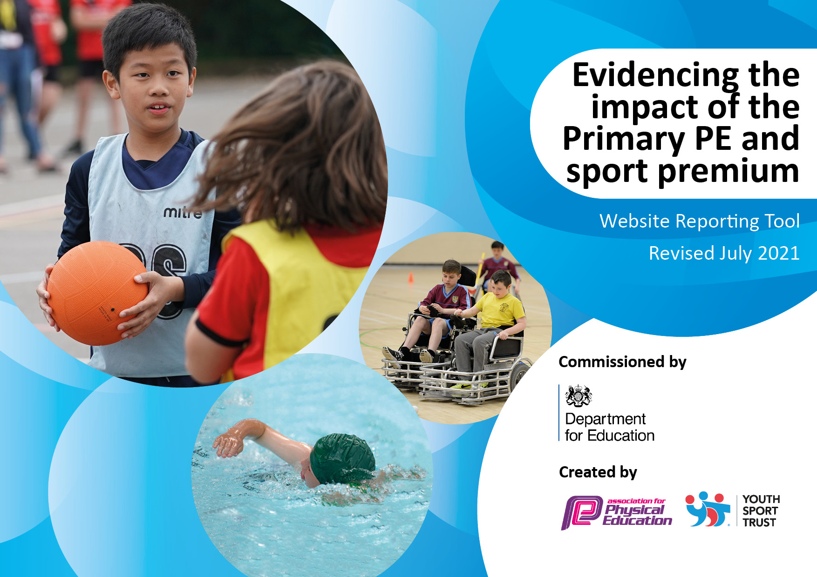
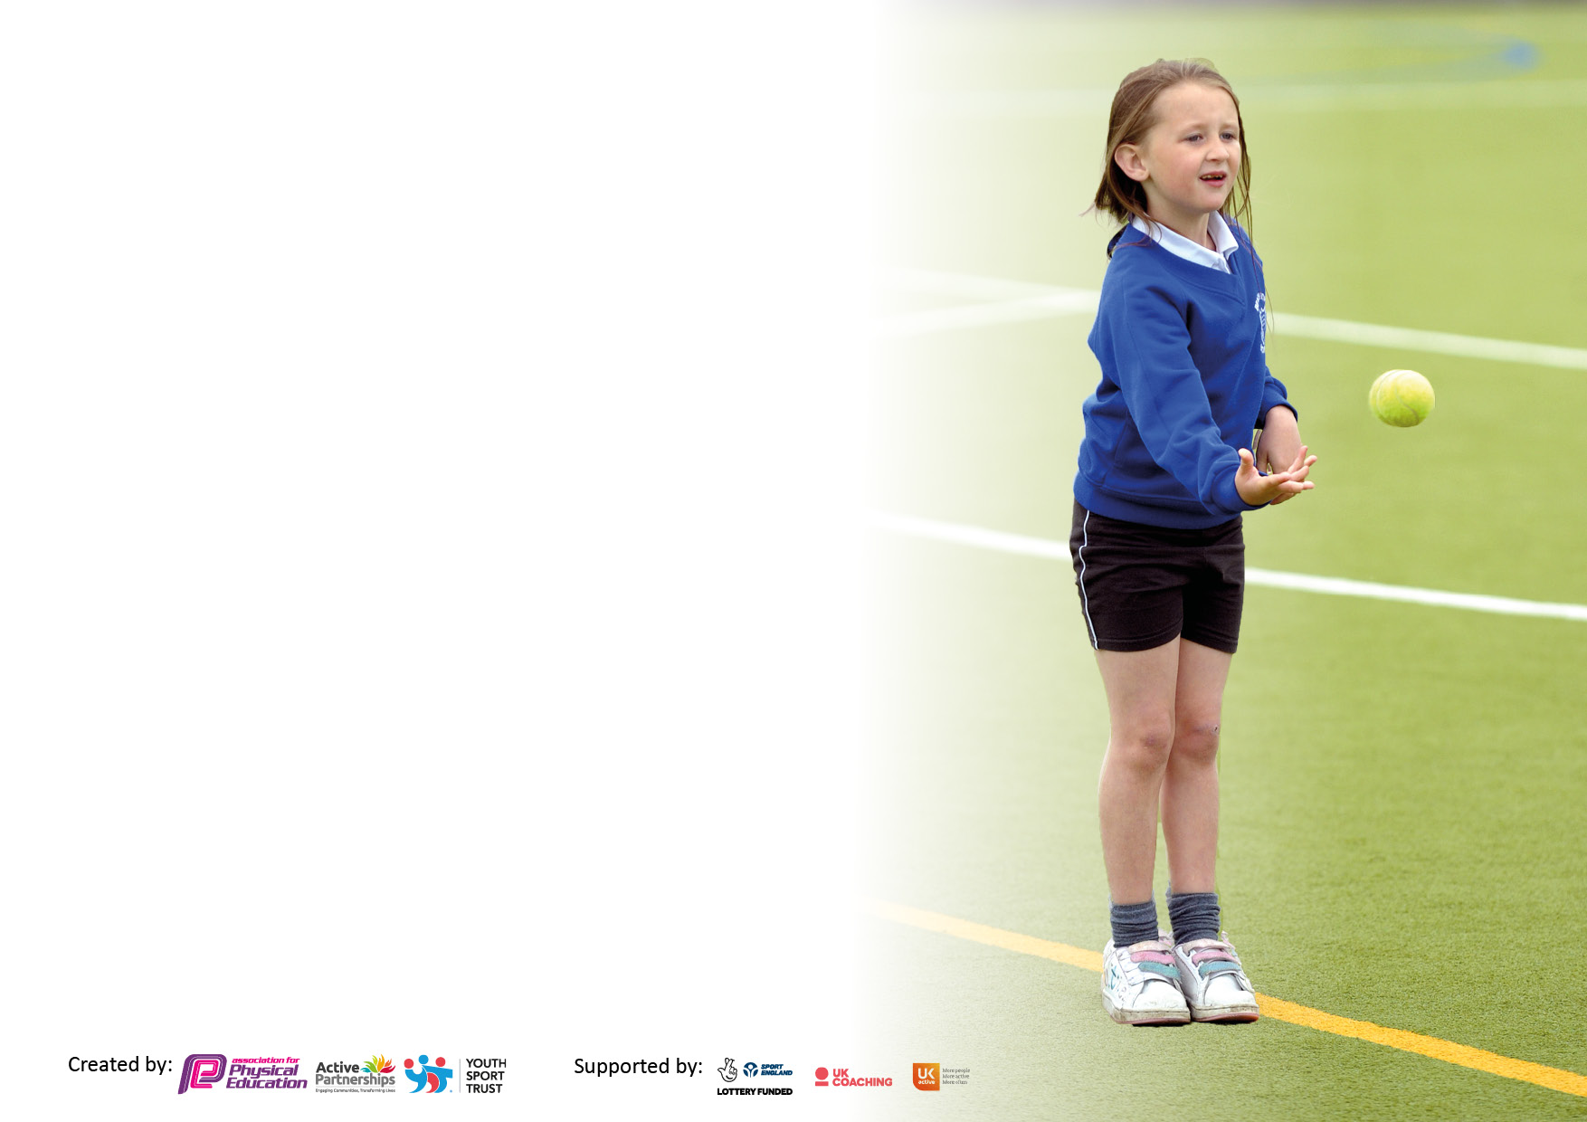

It is important that your grant is used effectively and based on school need. The Education Inspection Framework makes clear there will be a focus on ‘whether leaders and those responsible for governors all understand their respective roles and perform these in a way that enhances the effectiveness of the school’.

Under the Quality of Education Ofsted inspectors consider:
Intent - Curriculum design, coverage and appropriateness
Implementation - Curriculum delivery, Teaching (pedagogy) and Assessment
Impact - Attainment and progress

To assist schools with common transferable language this template has been developed to utilise the same three headings which should make your plans easily transferable between working documents.

Schools must use the funding to make additional and sustainable improvements to the quality of Physical Education, School Sport and Physical Activity (PESSPA) they offer. This means that you should use the Primary PE and sport premium to:

- Develop or add to the PESSPA activities that your school already offer
- Build capacity and capability within the school to ensure that improvements made now will benefit pupils joining the school in future years
- The Primary PE and sport premium should not be used to fund capital spend projects; the school’s budget should fund these.

Pleasevisitgov.ukfortherevisedDfEguidanceincludingthe5keyindicatorsacrosswhichschoolsshoulddemonstrate animprovement.Thisdocumentwillhelpyoutoreviewyourprovisionandtoreportyourspend.DfEencouragesschools to use this template as an effective way of meeting the reporting requirements of the Primary PE and sport premium.

We recommend you start by reflecting on the impact of current provision and reviewing the previous spend.

Schools are required to publish details of how they spend this funding, including any under-spend from 2019/2020, as well as on the impact it has on pupils’ PE and sport participation and attainment. All funding must be spent by 31st July 2023.

We recommend regularly updating the table and publishing it on your website throughout the year. This evidences your ongoing self-evaluation of how you are using the funding to secure maximum, sustainable impact. Final copy must be posted on your website by the end of the academic year and no later than the 31st July 2021. To see an example of how to complete the table please click HERE.
Created by: Supported by:

Details with regard to funding
Please complete the table below.

Total amount allocated for 2021/22 | £
How much (if any) do you intend to carry over from this total fund into 2022/23? | £
Total amount allocated for 2022/23 | £
Total amount of funding for 2022/23. To be spent and reported on by 31st July 2023. | £
Swimming Data
Please report on your Swimming Data below.

Meeting national curriculum requirements for swimming and water safety.

N.B. Complete this section to your best ability. For example you might have practised safe self-rescue techniques on dry land which you can then transfer to the pool when school swimming restarts.
Due to exceptional circumstances priority should be given to ensuring that pupils can perform safe self rescue even if they do not fully meet the first two requirements of the NC programme of study
What percentage of your current Year 6 cohort swim competently, confidently and proficiently over a distance of at least 25 metres?  N.B. Even though your pupils may swim in another year please report on their attainment on leaving primary school at the end of the summer term 2021.  Please see note above | %
What percentage of your current Year 6 cohort use a range of strokes effectively [for example, front crawl, backstroke and breaststroke]?  Please see note above | %
What percentage of your current Year 6 cohort perform safe self-rescue in different water-based situations? | %
Schools can choose to use the Primary PE and sport premium to provide additional provision for swimming but this must be for activity over and above the national curriculum requirements. Have you used it in this way? | Yes/No

Action Plan and Budget Tracking
Capture your intended annual spend against the 5 key indicators. Clarify the success criteria and evidence of impact that you intend to measure to evaluate for pupils today and for the future.

Academic Year: 2022/23 | Total fund allocated: | Date Updated: 31.08.2022
Key indicator 1: The engagement of all pupils in regular physical activity – Chief Medical Officers guidelines recommend that primary school pupils undertake at least 30 minutes of physical activity a day in school |  |  |  | Percentage of total allocation:
 |  |  |  | %
Intent | Implementation |  | Impact
Your school focus should be clear what you want the pupils to know and be able to do and about  what they need to learn and to  consolidate through practice: | Make sure your actions to achieve are linked to your intentions: | Funding allocated: | Evidence of impact: what do pupils now know and what can they now do? What has changed?: | Sustainability and suggested next steps:
A full time qualified Community Sports activator apprentice who helps teach and manages extra PE provision across the Academy is employed.  Improving equipment | Apprentice is to support in the teaching of PE across the school as well as run after school and lunch clubs.  Purchasing equipment to ensure that the right equipment is in use to deliver PE sessions and after school clubs. | £8,208  £1500
Key indicator 2: The profile of PESSPA being raised across the school as a tool for whole school improvement |  |  |  | Percentage of total allocation:
 |  |  |  | %
Intent | Implementation |  | Impact
Your school focus should be clear what you want the pupils to know and be able to do and about  what they need to learn and to  consolidate through practice: | Make sure your actions to achieve are linked to your intentions: | Funding allocated: | Evidence of impact: what do pupils now know and what can they now do? What has changed?: | Sustainability and suggested next steps:
In house tournaments, after school  clubs, PE lessons and Lunch clubs | Apprentice is to support in the  teaching of PE across the school as  well as run after school and lunch  clubs. Apprentice to run sports  display board in school.  HUB leader to support the  apprentice in the school. Run after  school club and lunch club.  Provide sporting events and  opportunities throughout the  year. Support the teachers with  CPD | £8,208

Key indicator 3: Increased confidence, knowledge and skills of all staff in teaching PE and sport |  |  |  | Percentage of total allocation:
 |  |  |  | %
Intent | Implementation |  | Impact
Your school focus should be clear | Make sure your actions to | Funding | Evidence of impact: what do | Sustainability and suggested
what you want the pupils to know | achieve are linked to your | allocated: | pupils now know and what | next steps:
and be able to do and about | intentions: |  | can they now do? What has
what they need to learn and to |  |  | changed?:
consolidate through practice:
Teachers will be supported and  more confident to deliver PE through:  Sessions delivered by the apprentice  Sessions delivered by coach from The Albion Foundation | Apprentice to provide support to the teachers in the school lessons.  TAF coach in once a week to provide extra CPD for teachers | £8,208  £2,880
Key indicator 4: Broader experience of a range of sports and activities offered to all pupils |  |  |  | Percentage of total allocation:
Intent | Implementation |  | Impact
Your school focus should be clear | Make sure your actions to | Funding | Evidence of impact: what do | Sustainability and suggested
what you want the pupils to know | achieve are linked to your | allocated: | pupils now know and what | next steps:
and be able to do and about | intentions: |  | can they now do? What has
what they need to learn and to |  |  | changed?:
consolidate through practice:
Additional achievements:  Apprentice to run a range of after school and lunch time clubs throughout the week.  The Albion Foundation to run an after school clubs once per week  Outdoor education | After school clubs to be offered to all year groups throughout a week. Lunch time club to be offered to children.  TAF to run a lunch time club and an after school club once per week. | £8,208  £2,880  £2,000

Key indicator 5: Increased participation in competitive sport |  |  |  | Percentage of total allocation:
 |  |  |  | %
Intent | Implementation |  | Impact
Your school focus should be clear | Make sure your actions to | Funding | Evidence of impact: what do | Sustainability and suggested
what you want the pupils to know | achieve are linked to your | allocated: | pupils now know and what | next steps:
and be able to do and about | intentions: |  | can they now do? What has
what they need to learn and to |  |  | changed?:
consolidate through practice:
Participation in competitions and  activities for Academy pupils.  Apprentice to organise sporting  Events. | Apprentice to support in the  running of both school games  events and BDMAT sporting  calendar.  Sports Days | £8,208  £875

Signed off by
Head Teacher:
Date:
Subject Leader:
Date:
Governor:
Date:

